
DEDAN KIMATHI UNIVERSITY OF TECHNOLOGY PROJECT PROGRESS PRESENTATION FOR FINAL YEAR STUDY IN B.Sc. BUSINESS INFORMATION TECHNOLOGY
POST DIAGNOSIS CHRONIC KIDNEY DISEASE PATIENT’S MANAGEMENT SYSTEM(TELEMED) -PROJECT PROGRESS PRESENTATION

STUDENT:
FREDRICK KARIMAH MWANGOLO
C027-01-2415/2022

SUPERVISOR:
MR. MIKE MUCHIRI.

A project progress presentation submitted to the department of Information Technology in the School of Computer Science and Information Technology in partial fulfillment of the requirements for the award of the degree of Bachelor of Science in Information Technology at Dedan Kimathi University of Technology.

DECEMBER,2025.

1. Abstract

Kidney dialysis patients face ongoing challenges in managing their health due to the complexity of treatment schedules, medication routines, and the need for constant monitoring. This project proposes a digital platform that empowers dialysis patients to actively participate in their care through a structured and AI-assisted health management system. The solution allows users to log daily symptoms and medications, which are then analyzed using machine learning algorithms to detect health trends such as improvement, stability, or deterioration. Based on these insights, the system provides timely recommendations on whether to consult a nephrologist and allows for seamless appointment booking. The platform is designed to be user-friendly, secure, and accessible, with a focus on reducing unmonitored health decline and improving patient-doctor communication. Through this integrated approach, the system aims to enhance the quality of care for dialysis patients, promote early intervention, and support informed clinical decision-making.

Table of Contents
Abstract 2
CHAPTER 1:
Background 4
1.1 Introduction 4
1.2 Problem Statement 5
1.3 Objectives 6
1.4 Scope and Justification 7
(I) Scope 7
(ii) Justification 8
CHAPTER 2:
Literature Review 10
2.1 History of patients Management App 11
2.2 Case Studies 13
2.3 Gaps in Existing Projects 14
2.4 Proposed System Architecture 13
CHAPTER 3:
Methodology 15
3.3 Software Development Model 15
3.4 Software Development Phases 16
CHAPTER 4:
Implementation 19
4.1 Resources 19
4.2 REFERENCES 22
4.3 Design 23
4.4 Achieved Objectives 28

CHAPTER 1

Background.
Post Diagnosis Chronic Kidney Disease Patient’s Management System

1.1 Introduction
Chronic kidney disease (CKD) is a critical medical condition and ongoing disease process that affects millions of people worldwide, with many dialysis patients regularly monitored with medical interventions in order to maintain optimal quality of life. To manage such an ongoing disease process requires strict adherence to taking medications, monitoring health status, and following up with a healthcare expert like a nephrologist on time. Many dialysis patients are expected to track their symptoms, keep track of medications taken, and recognize subtle changes in their health that may not be major but could negatively impact the health process.
Thereby comes a digital health support system (TeleMed) that enables dialysis patients to self-manage their health daily. This digital health support system harnesses AI-facilitated data(symptoms, signs and medication) analysis, and automated recommendation reports to assist in tracking personal health information, but it promotes early management or persistent of either personal exacerbations, or complications reducing patient outcomes, not to mention visits to the hospital emergency department.
TeleMed aims to:
- Reduce preventable complications
- Lower hospital admissions.
- Empower Chronic Kidney Disease patients in managing their own health.

1.2 Problem Statement
According to a study published in BMC Nephrology (2020), over 40% of chronic Kidney dialysis patients fail to consistently record and monitor their symptoms and medication adherence, increasing the risk of missed early warning signs and the likelihood of post-late detection complications. Symptoms such as fatigue, swelling, abnormal blood pressure, or fluid retention may appear clearly at first, but without structured monitoring, they can escalate into severe medical events requiring emergency care.
Traditional methods of health tracking like paper logs are often inconvenient, inconsistent, and prone to user error, especially for patients managing complex kidney dialysis schedules. This has contributed to research findings that show up to 30% of emergency hospitalizations among chronic kidney dialysis patients are preventable if early and smart monitoring is detected and addressed promptly.
Moreover, existing healthcare systems often lack intelligent tools for analyzing daily patient reported data in real time. Even when information is captured, it typically remains unstructured and under-utilized, offering little support for proactive care. At the same time, scheduling appointments with nephrologists can be delayed or fragmented, resulting in treatment gaps during critical moments.

1.3 Objectives

General Objective:
To develop an AI-assisted platform (TeleMed) for chronic kidney disease patients that enables daily health tracking, trend analysis, and appointment management to support timely medical intervention and improve patient outcomes.

Specific Objectives:
By the end of this project, the system will:
- Kidney patient’s will be able to key in their daily logs to the system:
Enable patients undergoing kidney dialysis to log their daily signs, symptoms, and medications through a user-friendly interface for consistent health monitoring.
- The system will be able to show the trend of their health Analysis:
Integrate AI models to analyze patient data over time and detect health trends such as fluid retention or abnormal blood pressure, enabling early detection of complications.
- The system will be able to recommend the CKD patients to book appointments with doctors:
Use AI-generated alerts to notify both patients and doctors when symptoms indicate a need for medical attention, prompting appointment recommendations.
- Doctors will have a real-time chat with the kidney patients:
Provide an integrated appointment booking feature within the platform to allow patients to easily schedule consultations with their nephrologists, ensuring continuity of care.
- The system will be able to Analyze the patient’s status according to the signs and symptoms logged in and also medication taken:
Provide an integrated analytical feature within the platform to allow patients to easily monitor their trend, whether improving or not.

1.4 Research Questions
- How can daily health logs (symptoms and medication) from kidney dialysis patients be effectively captured through a user-friendly digital interface?
- How can AI be utilized to monitor and analyze patient data trends to detect early signs of health deterioration?
- To what extent can AI-driven systems accurately recommend medical consultations based on patient-reported data?
- How can an integrated appointment booking system improve accessibility and efficiency in managing nephrology consultations?

1.4. Scope and Justification.

(i) Scope of the Project
This project is focused on designing and developing a patient’s health management/monitoring platform tailored for kidney dialysis patients. The platform will support the following key functionalities:
- Daily Symptom and Medication Logging
The system will enable patients to input daily health information, including physical symptoms (e.g., fatigue, swelling), emotional well-being, and medication intake. The interface will be simple and mobile-friendly to encourage regular usage.
- AI-Assisted Health Trend Analysis
An integrated AI module will analyze patients' logged data over time to detect patterns indicating improvement, stability, or deterioration of health. These insights will be presented in easy-to-understand feedback.
- Automated Doctor Recommendations
Based on AI analysis, the system will notify patients when their health data shows concerning trends that warrant immediate consultation with a nephrologist/Doctor.
- Appointment Booking
The system will allow patients to conveniently book appointments with kidney specialists through the platform, based on urgency levels flagged by the AI.
- User Role Management
The platform will support different user roles, particularly patients and doctors, each with tailored access to data and functionalities relevant to their role.
TeleMed will be designed for individual outpatient use, particularly those receiving dialysis at home or visiting clinics periodically. The backend will be developed using Flask (Python), while MySQL will manage structured data storage. Frontend technologies will include HTML, CSS, and JavaScript with potential for integrating charting libraries for data visualization.

(ii) Justification of the Project
- Rising Burden of Kidney Disease
Chronic Kidney Disease (CKD) and end-stage renal disease are on the rise globally, especially in low- and middle-income countries. Dialysis patients often lack consistent self-monitoring, which leads to preventable emergencies and poor treatment outcomes. A digital system that supports proactive care can make a measurable impact.
- Gaps in Current Digital Solutions
While several apps exist for health tracking or chronic illness management, few if any are purpose-built for dialysis patients. Most lack tailored symptom fields, nephrologist-specific integration, or real-time AI feedback that empowers patients to understand their condition dynamically.
- Preventing Emergency Deterioration
Dialysis patients are vulnerable to rapid health deterioration if symptoms like shortness of breath, low blood pressure, or swelling are not addressed early. AI-powered analysis can help detect red flags in time and prompt necessary care, reducing hospitalization rates.
- Improved Doctor-Patient Engagement
With real-time symptom logs and intelligent health summaries, nephrologists can make better-informed decisions during appointments. This project will bridge the gap between visits and improve communication.
- Empowerment Through Data
Patients often feel powerless in managing chronic conditions. A system that not only tracks data but provides meaning through analysis gives patients more control and awareness of their own health journey.
- Scalability and Public Health Impact
Although starting with a focus on dialysis, the modular nature of the system allows for future expansion to cover other chronic conditions such as diabetes or hypertension. Therefore, the solution has long-term potential to influence digital chronic care in broader contexts.

CHAPTER 2

2. Literature Review

2.1 History of patient’s managements application
The development of patient management applications has evolved significantly over the past few decades, beginning with basic electronic health record (EHR) systems in the 1960s. Early systems, such as those developed by the Mayo Clinic and Massachusetts General Hospital, focused primarily on digitizing patient data for internal use. As computing advanced in the 1980s and 1990s, hospital information systems (HIS) began integrating scheduling, billing, and laboratory management, though patient-facing functionalities remained minimal.
The rise of the internet and mobile technology in the early 2000s led to the introduction of Personal Health Records (PHRs), such as Microsoft HealthVault and Google Health. These allowed patients limited access to their health information, but adoption was slow due to usability issues and data fragmentation.
In the 2010s, with the advent of smartphones and wearable devices, patient management apps became more interactive and patient-cantered. Apps like MyChart and Apple Health allowed users to track appointments, medication, and vitals. These platforms emphasized remote monitoring, secure messaging with healthcare providers, and integration with hospital EHR systems, leading to improved patient engagement and chronic disease management.

2.2 Case Study
Digital health technologies are increasingly being leveraged to support the management of chronic illnesses, including Chronic Kidney Disease (CKD). Multiple systems have emerged to assist in patient monitoring, medication adherence, and clinical coordination. However, most solutions lack condition-specific intelligence, real-time analysis, or seamless integration with nephrology care workflows. The following case studies explore existing platforms and their limitations in the context of kidney dialysis patient support.

Case Study 1: General-Purpose mHealth Apps
MyChart, Care Clinic, Medisafe
These applications allow users to log symptoms, medications, and lifestyle data. They include features such as medication reminders, symptom logs, and progress reports. While broadly useful, they are:
- Designed for general chronic conditions, not tailored to dialysis-specific needs.
- Lack specialist integration, such as nephrologist access.
- Do not offer real-time AI analysis or early-warning feedback mechanisms.
Gap: No personalized AI-driven trend monitoring or kidney-specific triage capability.

Case Study 2: Kidney-Focused Health Platforms
RenalTracker, Kaiser Permanente’s Renal Program, MyKidneyCoach
These systems target CKD patients more directly.
For instance:
- RenalTracker provides dietary education and symptom journaling but is passive and does not alert patients to urgent issues.
- MyKidneyCoach includes symptom tracking but lacks machine learning and predictive features.
Gap: These systems lack dynamic AI-based analysis and real-time alerts that inform both patients and clinicians about health deterioration.

Case Study 3: AI in Chronic Disease Management
IBM Watson Health, Google Health Predictive Models
These technologies demonstrate the potential of AI in chronic care. Use cases include:
- Predicting hospital readmissions,
- Detecting medication non-adherence,
- Monitoring risk in heart failure and diabetes.
A 2020 study in BMC Nephrology used machine learning to predict mortality in dialysis patients using historical clinical data.
Gap: These models are typically used in clinical settings by professionals not integrated into everyday patient self-monitoring systems.

Case Study 4: Appointment Scheduling Tools
Zocdoc, HealthTap
These platforms offer user-friendly interfaces for booking doctor appointments. However:
- They are general-purpose and not connected to a patient's symptom trends.
- They do not use AI to recommend or prioritize urgent nephrology consultations.
Gap:
Lack of symptom-to-action integration i.e., no AI-based recommendation that bridges symptom logging with urgent bookings.

2.4 Proposed Architecture

TeleMed is a digital health management platform focused on supporting kidney dialysis patients. It is designed to collect daily patient inputs, analyze trends using AI, and facilitate interactions with nephrologists through appointment bookings. The system emphasizes usability, timely health insights, and integration of intelligent feedback mechanisms.

System Components:
- Frontend (User Interface):
  - Technology: HTML5, CSS3, JavaScript, Bootstrap
  - Purpose: Allows patients to log daily health data, view AI health analysis results, receive recommendations, and book doctor appointments.

- Backend (Application Logic):
- Technology: Python with Flask Framework
- Responsibilities:
  - Receives and processes form data from the frontend.
  - Triggers AI analysis on user data.
  - Stores and retrieves patient data from the database.
  - Sends alerts or recommendations based on AI results.
- Database:
- Technology: MySQL
- Usage: Stores user profiles, medication logs, symptom records, AI analysis history, appointment data, and doctor information.
4.AI Module:
- Tools: LLMS :Gemini/Open AI
Functionality:
  - Analyze trends in patient-reported symptoms and medication adherence.
  - Identify risk patterns indicating stable, improving, or deteriorating health.
  - Provide interpretable output and feedback messages
5. Appointment Management Module:
- Built into the backend.
- Enables patients to view nephrologist availability and book sessions.
- Sends confirmation messages.

CHAPTER 3

3. Methodology.

3.0 Introduction
This chapter presents the methodology used in the development of TeleMed.
It outlines the research design, data collection methods, software development model, and phased approach to design, build, test, and deploy the system. Ethical considerations and progress tracking mechanisms are also discussed.

3.1 Research Design
The research employed a Descriptive Research Design, chosen for its suitability in understanding user needs through observational and survey data. This design was effective in revealing patient behaviour, pain points in health tracking, and how technology can improve chronic care management.
Justification:
- Detailed User Insight: Helps uncover the health routines, medication adherence, and challenges faced by dialysis patients.
- Low-Cost & Accessible: Ideal for academic research and constrained project budgets.
- Data Interpretability: Simplifies analysis of structured and semi-structured health data.
- Feature Alignment: Guided the design of the AI module, patient dashboard, and booking system.

3.2 Data Collection Methods
Both primary and secondary data collection methods were utilized.

3.2.1 Secondary Data
Secondary research involved reviewing:
- Peer-reviewed journals on chronic disease management and AI in healthcare.
- Mobile health (mHealth) applications such as MyKidneyCoach, CareDx AlloCare, and MyChart.
- Clinical guidelines from National Kidney Foundation (NKF) and WHO.
This provided insights into current solutions and best practices.

3.2.2 Primary Data
Primary data was obtained from:
- Clinician Feedback: Informal interviews with nephrologists and clinical medics to understand monitoring gaps and desired patient self-reporting features.

3.3 Software Development Model
Agile methodology is adopted to facilitate iterative development, user feedback integration, and continuous enhancement of features critical to dialysis patients.
Agile Justification:
- Allows for rapid updates based on clinician/patient feedback.
- Sprint-based cycles help prioritize modules like AI analysis and appointment booking.
- Enables progressive testing of AI feedback accuracy and patient interaction flow.

3.4 Development Phases

Phase 1: Requirement Gathering
- Requirements were gathered from survey insights, user interviews, and clinical consultation(DeKUT Medical Centre).
- Core features identified:
  - Daily logging of medication and symptoms
  - AI trend analysis
  - Appointment booking system
- AI use cases were documented, e.g., detecting health deterioration trends and recommending medical reviews.

Phase 2: Design
- AI response flows were designed to simulate conversations such as:
  - “You have reported fatigue for 3 days. Would you like to book a doctor’s appointment?”
- A MySQL database schema was designed to store health logs, patient profiles, and AI outputs.
- System architecture included backend (Flask), frontend (HTML/CSS/JS), and AI module integration.

Phase 3: Development
- Frontend: Developed using Bootstrap, HTML, and JavaScript for responsiveness and accessibility and UI.
- Backend: Built with Flask (Python) due to its lightweight nature and ease of integrating ML models.
- Database: MySQL used for managing user profiles, logs, and appointment records.
- AI Module: Trained on synthetic and open-source chronic illness symptom datasets. The model predicts health status trends (e.g., worsening/stable/improving).

Phase 4: Testing
- Unit testing was applied to individual components like symptom logging, appointment scheduling, and AI prediction outputs.
- User Acceptance Testing (UAT): Conducted with dialysis patients and clinicians to validate AI recommendations and system usability.
- Bug Fixes & Iteration: Changes were made based on user feedback to improve prompt clarity and interface flow.

Phase 5: Deployment
- The system was deployed on a local server and hosted web interface, accessible on both desktop and mobile devices practicality was confirmed using NGROK.
- Patients interacted with the system through real-life simulation and dummy health logs.
- Feedback from early deployment helped refine the AI threshold for when a consultation is recommended.

3.5 Ethical Considerations
- Consent: Participants involved in interviews and testing provided verbal or written consent.
- AI Transparency: Patients are informed that AI suggestions are non-diagnostic and advisory in nature.
- Security: No sensitive health credentials or diagnostic decisions are stored or made by the system.

CHAPTER 4

Implementation.

4.1 Resources
TeleMed utilizes a combination of software and hardware resources essential for designing, developing, testing, and deploying a functional web-based health management application. These resources are categorized as follows:

4.1.1 Software Resources

1. Programming Languages / Frameworks
I will use the following programming languages and frameworks to implement the project objectives
- Back-end:
  - Python 3.11 with the Flask web framework
This will be used for the backend design and framing of the UI/UX for responsive of web and mobile interface.
- Front-end:
  - HTML5, CSS3, JavaScript with Bootstrap 5
This will be used for the design and implementation of the UI/UX.
- AI/ML Integration:
  - Gemini 2.5 will be used for the analysis of the daily logs and medication taken from the users (Patients) and it will be resourceful for the recommendation generation for faster doctor act.
- APIs:
  - Flask RESTful AP. This will be ideal for backend/frontend communication for easy communication between the client and server side.

2. Database Management
- Main Database:
  - MySQL:this will be used for managing user profiles, health logs, medical history, and appointment records and the recommendations generated by the nephrologists

3. AI Tools and Libraries
- Trend Analysis Engine:
Gemini 2.5 will be used for the analysis of the daily logs and medication taken from the users (Patients) and it will be resourceful for the recommendation generation for faster doctor act
- Natural Language Interaction.
  - A rule-based engine mimicking chatbot-like prompts (e.g., recommending medical reviews when risk levels rise).

4. Development Tools
- Version Control:
  - Git & GitHub This will be used for collaborative code management and backup when a disaster occurs
- IDE:
  - Visual Studio Code with Python, Flask, and MySQL extensions

4.1.2 Hardware Resources
- Development Machine:
  - Laptop with Intel i5 processor, 8GB RAM, and 256GB SSD, capable of running Python applications, database servers (MySQL), and AI integration.

Scheduling

Duration | July | August | October | November | November
Task
Project proposal writing and Presentation
Research
Analysis
Design
Development
Deployment

4.1 REFERENCES

1.Silva, B. M., Rodrigues, J. J., de la Torre Díez, I., López-Coronado, M., & Saleem, K. (2015). Mobile-health: A review of current state in 2015. Journal of Biomedical Informatics, 56, 265–272. https://doi.org/10.1016/j.jbi.2015.06.003
2. Kumar, S., Nilsen, W. J., Abernethy, A., Atienza, A., Patrick, K., Pavel, M., ... & Hedeker, D. (2013). Mobile health technology evaluation: The mHealth evidence workshop. American Journal of Preventive Medicine, 45(2), 228–236. https://doi.org/10.1016/j.amepre.2013.03.017
3 Maher, N. A., Senders, J. T., Hulsbergen, A. F. C., Lamba, N., Parker, M., Onnela, J. P., & Smith, T. R. (2021). Passive data collection and use in healthcare: A systematic review of ethical issues. International Journal of Medical Informatics, 143, 104239. https://doi.org/10.1016/j.ijmedinf.2020.104239
4 Lin, Y., & Lee, M. (2020). Using artificial intelligence to monitor patients with chronic kidney disease: A machine learning approach. Health Informatics Journal, 26(1), 403–417. https://doi.org/10.1177/1460458219832041
5.Ghassemi, M., Naumann, T., Schulam, P., Beam, A. L., Chen, I. Y., & Ranganath, R. (2018). Opportunities in machine learning for healthcare. arXiv preprint arXiv:1806.00388. https://arxiv.org/abs/1806.00388

4.2 Design.

4.2.1 UML Process Design


Login
Log Daily Symptoms
Book Appointment
View Lab Results
Contact Care Team
View AI Advice
Approve Appointment ms
View Logs
Give Recommendations
View Assigned Patients
DOCTORS
PATIENTS/CAREGIVERS


Upload Lab Results Respond to Messages

Analyze Logs, Provide Advice



AI MODEL

Class diagrams
The class diagram models the main entities of the TeleMed system such as Patient, Doctor, Health Log, Appointment, and AIAnalysis. It shows their attributes and relationships, ensuring clear data organization.

Patient
Patient_id
name
email
password
doctor_id
+Login ()

AIAnalysis
analysis_id
patient_id
trend_score
ai_message
date
+Login ()

Doctor
doctor_id
name
specialization
email
password

+Login ()

Message
Id
patient_id
recipient_id
subject
body
date
+DisplayMessage ()

LabResult
id
patient_id
test_name
value
unit
ref_range
notes
date
+AddResults ()

HealthLog
log_id
patient_id
symptoms
medication
date

+registerLogs()

Appointment
Id
Patient_id
doctor_id
date
time
status
+AddAppoointment()

Recommendation
id
patient_id
doctor_id
advice
date

DFD (Logical Flow)
The data flow diagram represents the logical flow of data between external entities (Patient, Doctor, Nurse, AI) and processes (Authentication, Health Logs, Appointments, Labs, Messages, AI Analysis).
Database
AI(Gemini)
Lab Results
Care Team (Nurse)
Doctor
Authentication
Messages
Patient
AI Analysis
Health Logs
Appointments
Sequence Diagram
The sequence diagram demonstrates the appointment booking process, showing the interaction between the Patient, System, Database, and Doctor, including booking, saving, notification, and approval
Book Appointment (date, time)
Save Appointment
Notify new Appointment
Confirmation/Rejection
Approve/Reject
Database
Doctor
System
Patient

Activity Diagram
The activity diagram illustrates the workflow of a patient within the system. It includes login, logging symptoms, booking appointments, viewing lab results and AI advice, and messaging the care team.
View Lab &TeleMed Advice
End
Message Care Team
Book Appointment
Authenticated?
Login
Start

4.2 Object Achieved/Output

Home page of the system
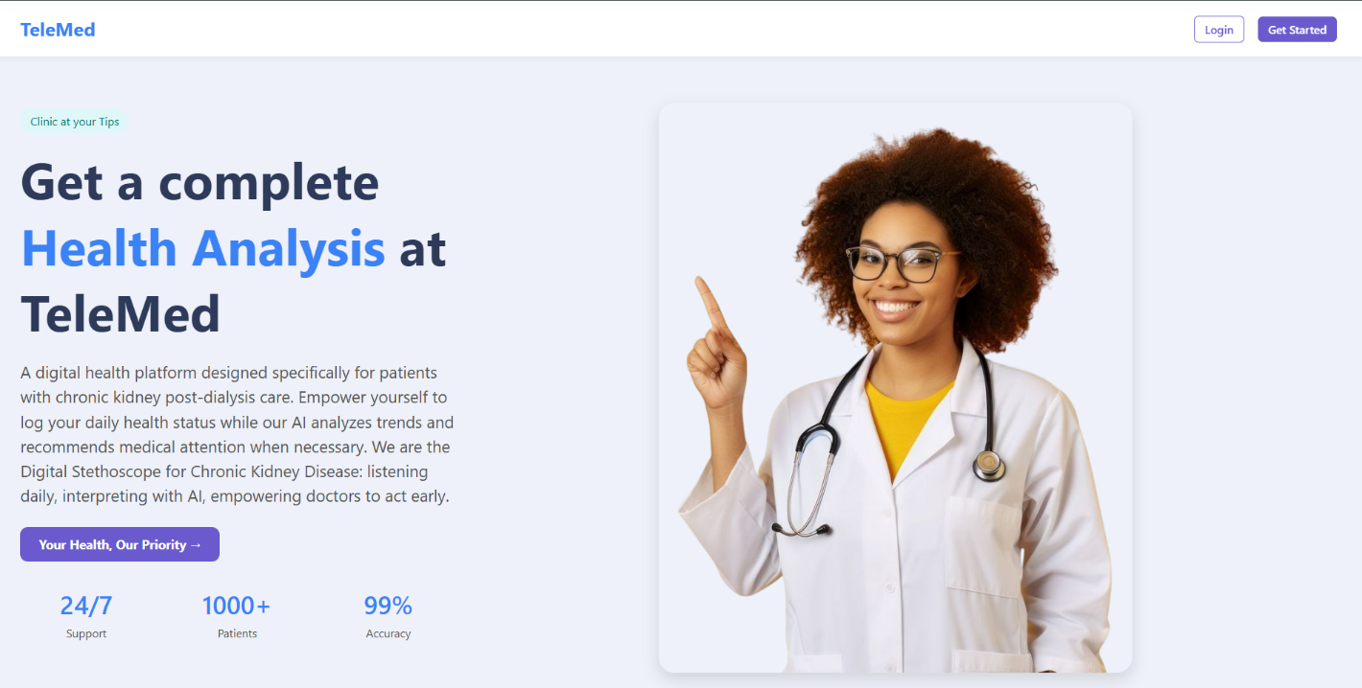

Login interface of the system.

(One can log in as Doctor, Patient or Caregiver)

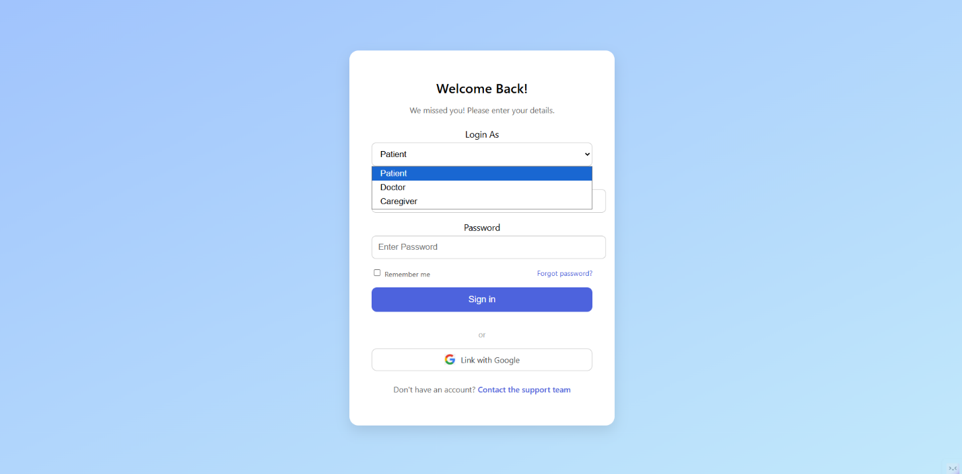

Patient’s Dashboard (i.e. can log daily logs, book appointment, see his/her health trend)

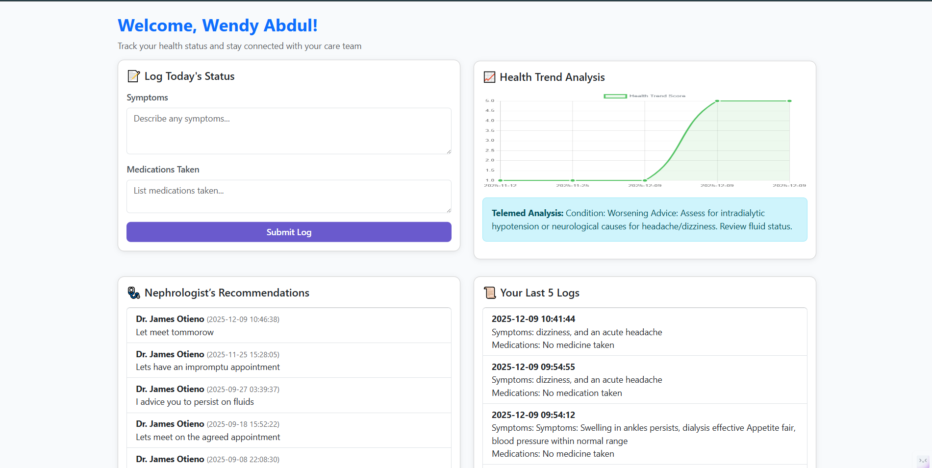

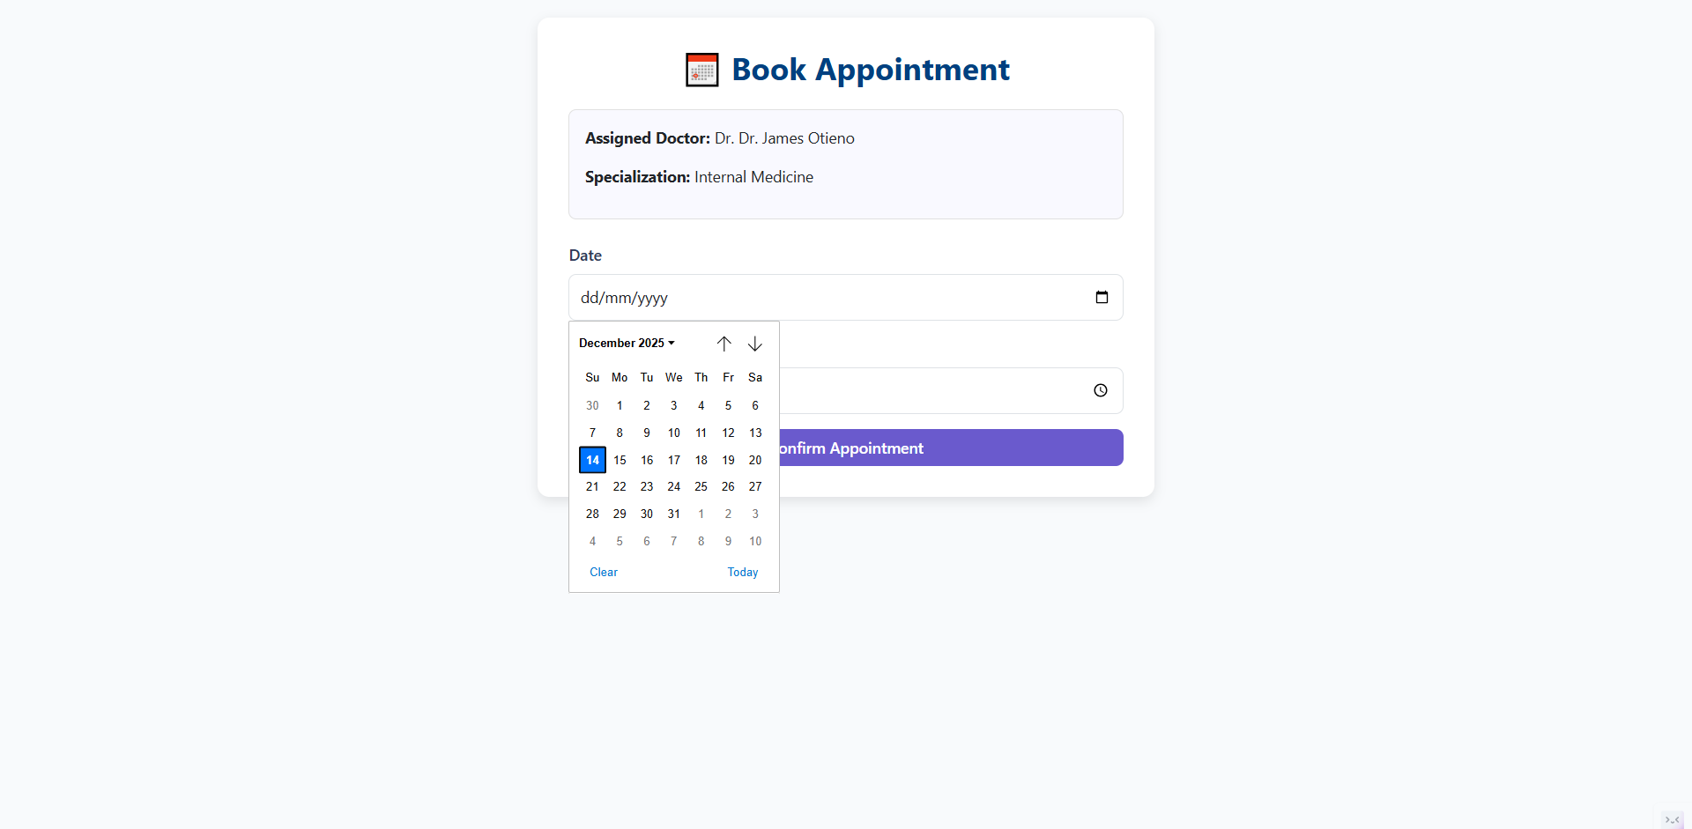

Doctor’s Dashboard (i.e. can monitor daily logs, approve/ reject appointment, give recommendations based on and get AI recommendation.)

